Lab 4: Resizing of Storage Feature in Azure Virtual Machine

Theory
Azure Virtual Machines (VMs) provide flexible and scalable storage options through Azure Managed Disks. Each VM is attached to one or more virtual disks—OS disk, data disks, and temporary disk—whose size and performance characteristics can be modified as needed. Resizing storage means increasing (or sometimes decreasing, depending on disk type) the capacity or performance tier of a disk attached to a VM.
Azure supports several disk types:
- Standard HDD – low-cost, basic performance
- Standard SSD – reliable performance for general workloads
- Premium SSD / Premium SSD v2 – high performance for production workloads
- Ultra Disk – extremely high throughput and low latency
Key concepts:
- Disk Size: Measured in GiB; increasing size is supported for all managed disk types.
- Disk Performance: Each disk type has limits for IOPS and throughput; resizing may increase these limits.
- Online Resize: Many disk size changes can be done without shutting down the VM.
- Filesystem Expansion: After increasing disk size, expanding the filesystem inside the VM is required to use the new space.
Resizing is helpful when:
- The VM is running out of storage space
- Applications require higher I/O performance
- Workloads change and demand more capacity

Steps
- Observe the size of the virtual machine before resizing:
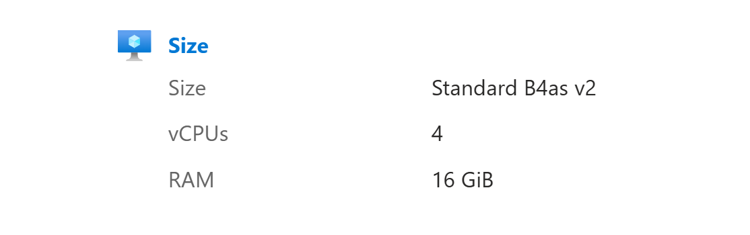

- Click on the Size option of the virtual machine and choose among the available sizes in order to resize it as per your requirements:

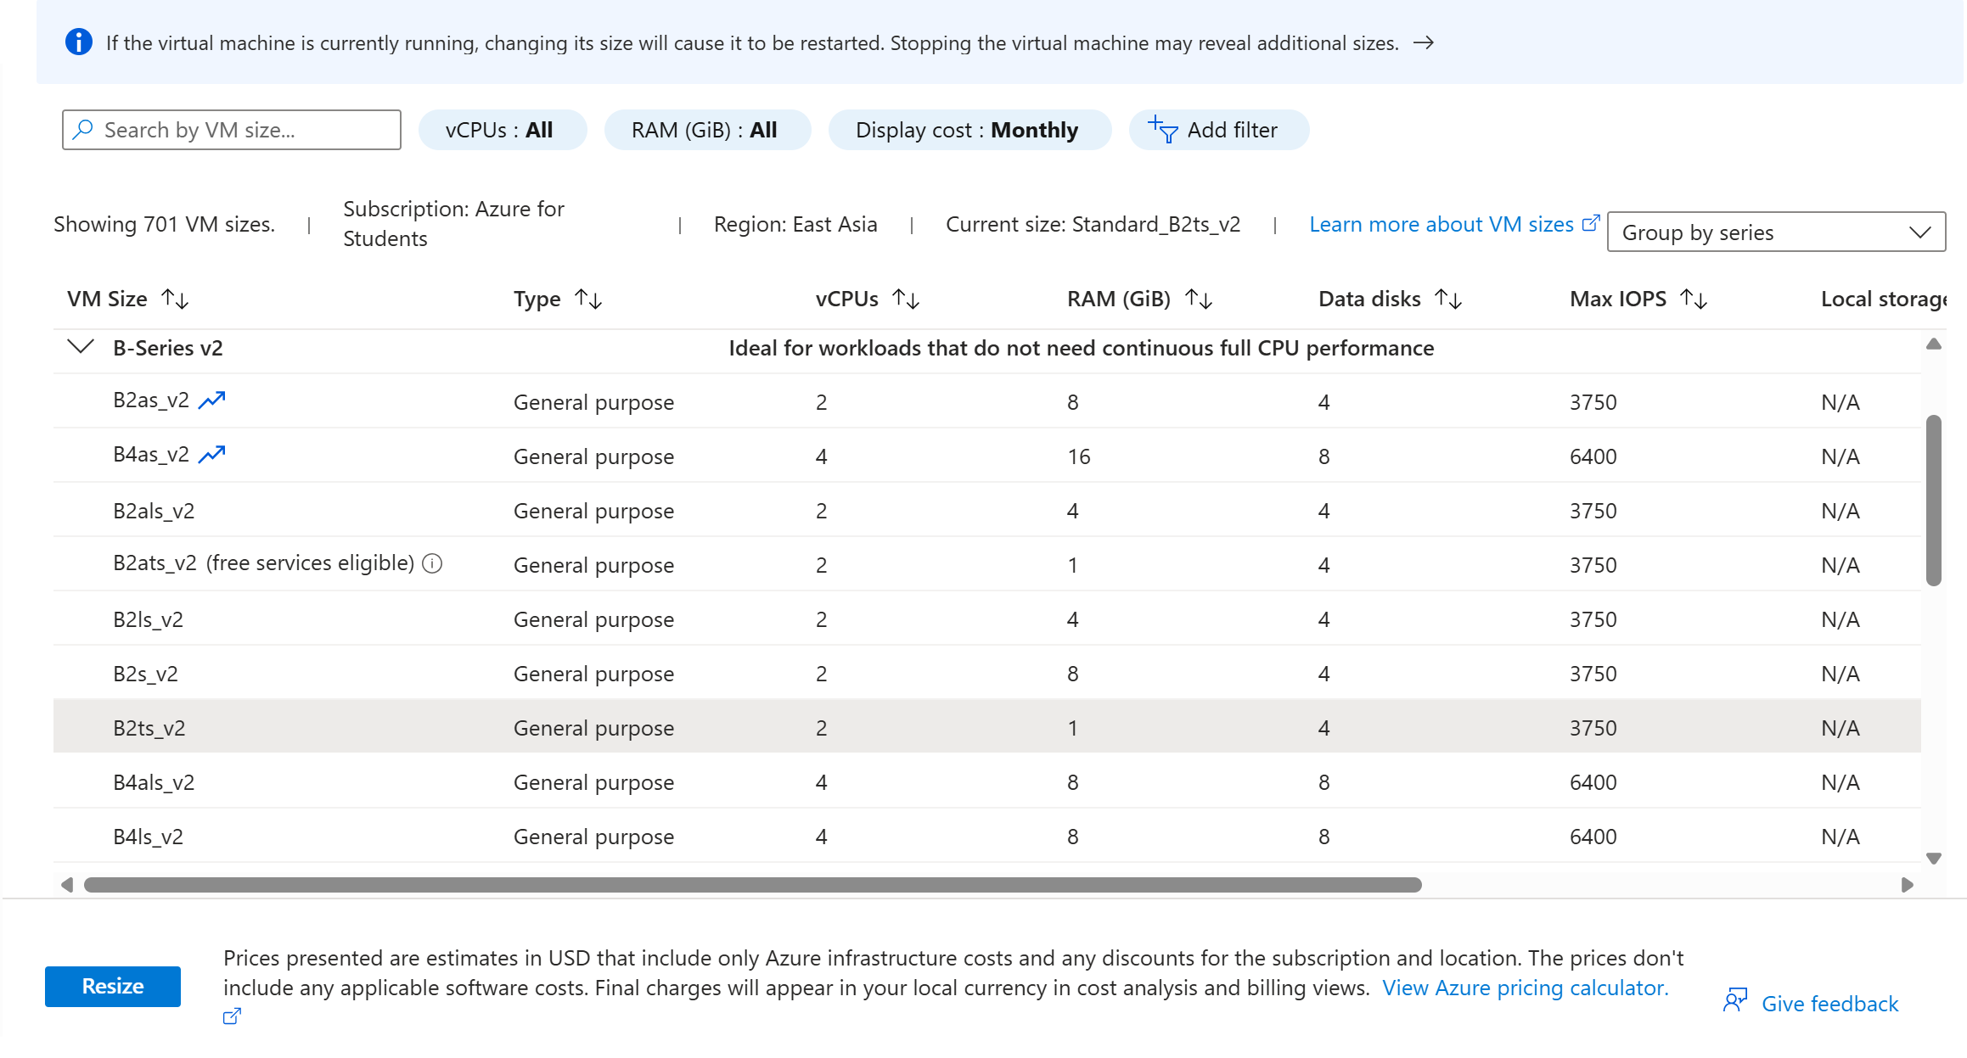

- Once the previous step is successful check whether your virtual machine has been resized or not:
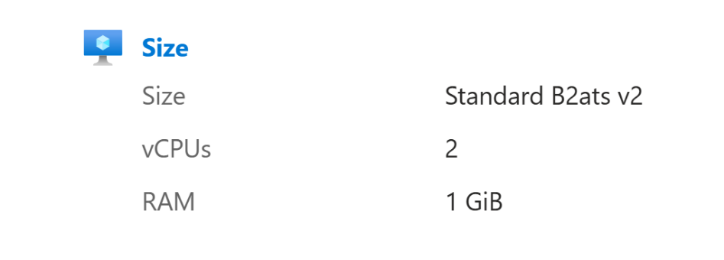
Result and Conclusion:
Result: During the lab exercise, the disk attached to the Azure Virtual Machine was successfully resized using the Azure Portal. The OS/Data disk capacity was increased to a larger size. Azure automatically updated the managed disk configuration, and the VM recognized the expanded disk. After resizing, the filesystem inside the VM was extended to utilize the additional storage.
The VM remained functional during and after the resizing operation, confirming that Azure supports seamless disk expansion without affecting VM availability (depending on OS and disk type).
Conclusion: The lab demonstrated that Azure provides a simple and efficient way to scale storage for Virtual Machines by resizing managed disks. The process requires minimal downtime and can be performed directly through the Azure Portal. Resizing ensures that VMs can adapt to growing storage and performance demands. Understanding this feature is essential for managing cloud infrastructure, optimizing resources, and maintaining application performance.

